***Tree Inventory Export Application***

**Introduction**

The Northeast Ohio Regional Sewer District (The District), managed by the Sustainability & Special Projects department, will begin an inventory of trees located on their properties in 2023. As of Q1 2023, the District owned 396 parcels spanning over 575 acres across its service area. Currently, trees are managed by various District departments depending on where they are located, thus there is a lack of consistent oversight or understanding of the District’s canopy. The 2023 Tree Inventory will provide the District with a holistic knowledge of its tree canopy, allowing it to:

* Enhance understanding of properties that could host additional trees to expand the District’s tree canopy, with a focus on neighborhoods that have a low percentage of tree canopy and/or areas that are prone to flooding.
* Utilize data to refine greenhouse gas emissions reporting by incorporating carbon sequestration.
* Utilize data to calculate overall stormwater capture of District’s tree canopy.
* Evaluate properties that require tree pruning, treatments for disease/pests/invasive species, successional planting, in addition to determining if specific species are outperforming others.
* Tabulate number of each tree species surveyed to guide decision-making when choosing species to plant to increase the biodiversity of the District’s canopy (e.g. the 10-20-30 rule of urban forestry).
* Research and consider selling carbon offsets to maintain and expand the District’s canopy.
* Share tree canopy data with local and regional organizations, such as the Cleveland Tree Coalition.

**Tree Inventory Export Application Purpose:**

This application was created to help make the exporting of the weekly Tree data CSV reports a more hands on process for Sustainability & Special Projects department. It was also created to help align with their table format that was used in past exported versions.

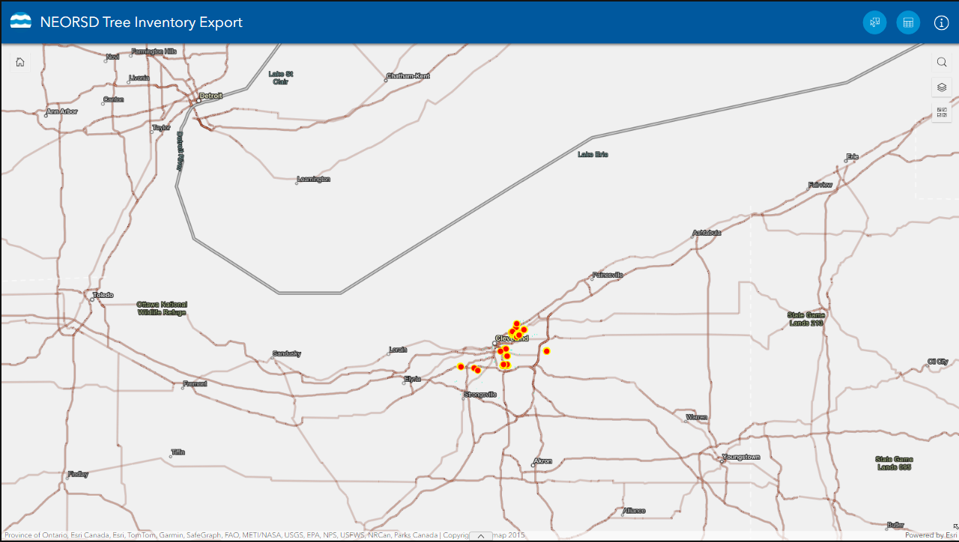

**Getting started:**

* Sign into ArcGIS online
* Go to Content
* My organization
* Search for the NEORSD Tree Inventory Export application
* Select the application and then select View

**Clearing the Disclaimer**

* When launching the app, you are greeted with our disclaimer, and how to contact us for more information.
* Click anywhere outside of the window to close the disclaimer.

**Application Layout:**

There are three buttons at the top right corner of the application that perform different functions.

**The Select button** opens the selection tool window.

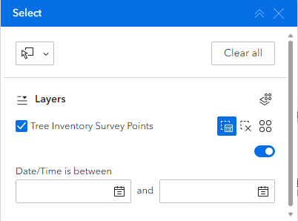

There are two ways to select a record or records for export:

**Select by shape** (rectangle, lasso, circle). This method allows users to select specific trees by drawing a circle around them. After a selection is made the table with selected records will pop up.

**Attribute Selection** (Date/time is between) This option allows you to select by a specific date and time frame. After a timeframe is defined those tree inspections done during that time will be selected and the table will pop up with the selected records. To activate this method of selection be sure to turn on the toggle switch.

**Reviewing and Exporting the Selection:**

* **A picture containing graphical user interface

  Description automatically generated**When a Selection is made the table with all the records will populate.
* Select the waffle button on the right of the table or in the selection tool window.



* Graphical user interface, application

  Description automatically generatedFrom the selection options choose **Export** and then **Export to CSV.**
* To open the file, choose the open file in the download history in your browser.

**The Table Button**:opens the table with the selected record.

* Only records that are selected will show up in this table.

**\*Tips:**

* To export all the records, use **the select by shape tool** and draw a circle or square around all the records or set the date between the beginning of the year until the present in the **attribute selection tool**.
* To clear a selection, use the clear all button in the table or Selection Tool.

**The Information button:** This button opens the disclaimer window.

