**How to Create Prints in the NEORSD GIS Viewer**

Choose Print Icon 

Choose appropriate Layout from dropdown menu:

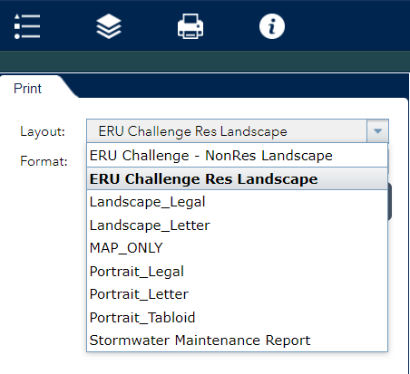

Depending on your template choice, there will be custom text options to fill out.

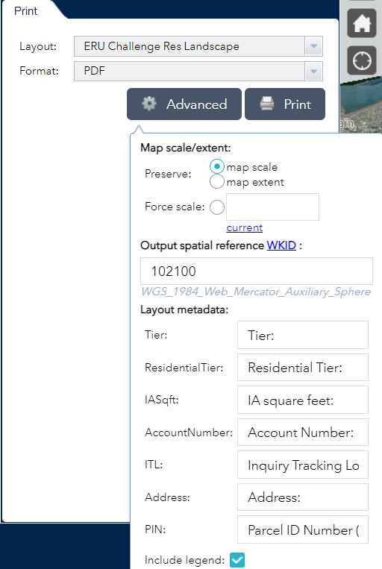

Displays as “1234”

Displays as “Tier: 1234”

To include text, please leave text in fillable box.

To not include text, please delete text in fillable box.

When the Advanced options have been completed, click Print:

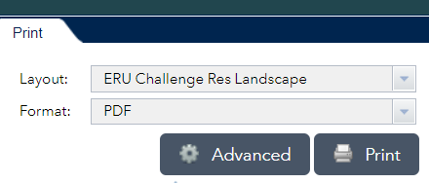

A dialog box will show your print is being created:

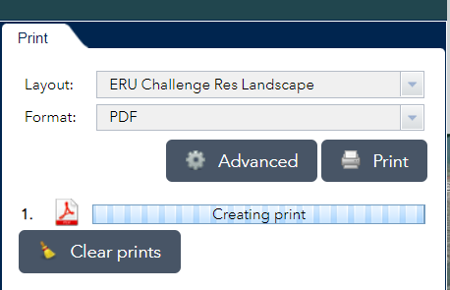

Your new print will display when completed:

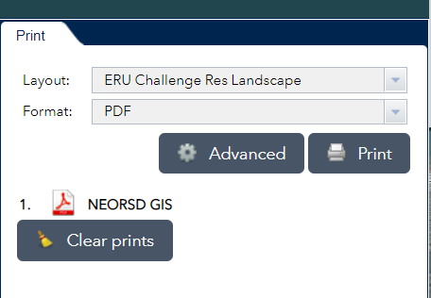

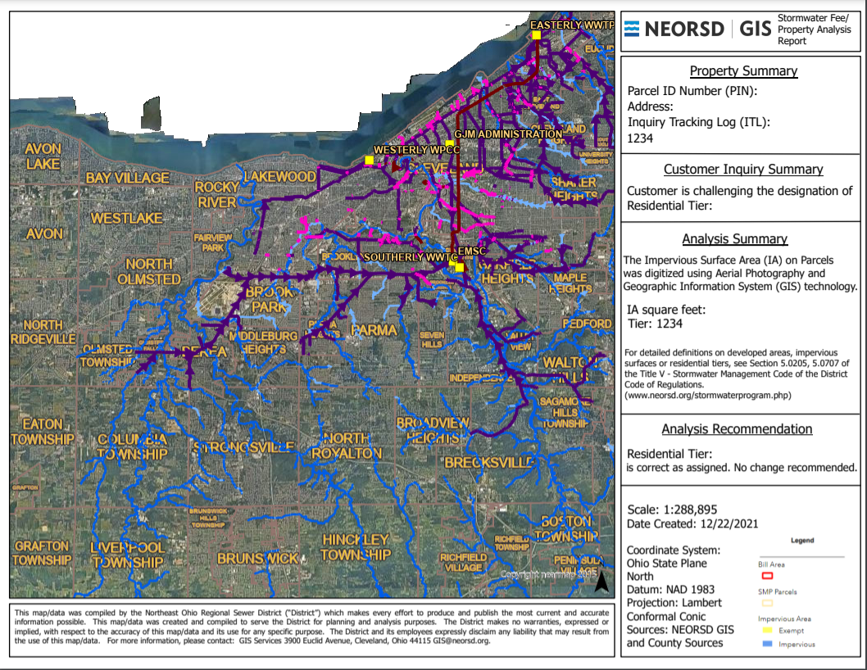

**Displays as “1234”**

**Displays as “Tier: 1234”**

If you have multiple prints and would like to clear them, the Clear Prints option will erase all recent prints.

