**Field Maps How-To Guide**

Use Apple App Store or Google Play to search for and download ArcGIS Field Maps.

Once downloaded, open application and sign in using your ArcGIS Online sign on credentials.

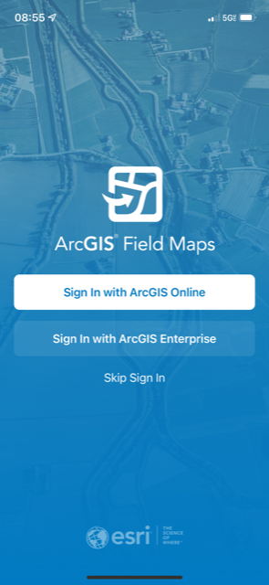 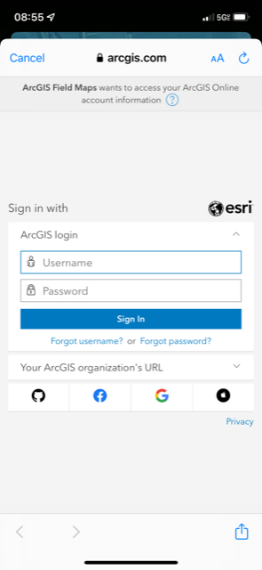

Once logged in, you will see available Maps and Groups. The ellipses next to each map will expand more options for the maps including View Details, Favorite and Reload Map (refreshes and opens map).

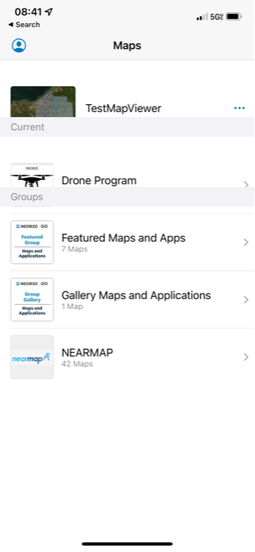 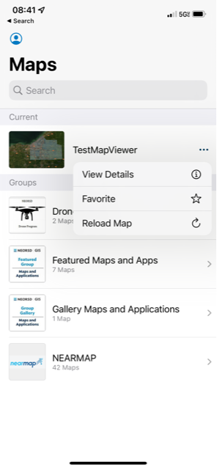

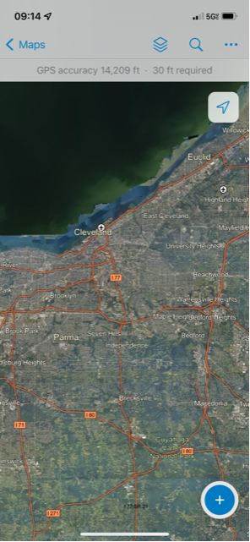

 Maps button – returns you to the menu to choose another map or Group.

 Layer List – shows layers within map and allows toggle on/off of each layer.

 Search – allows search of address.

 Ellipses – expands additional menu options.

 Collect – allows data collection on visible and available layers.

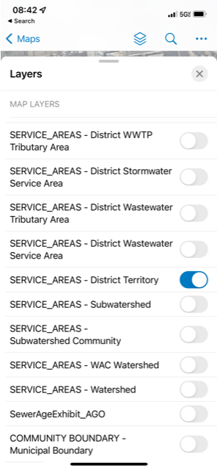

Layer List – click icon to expand layer list

Use toggle buttons to turn on/make layer visible and available for data collection or edits

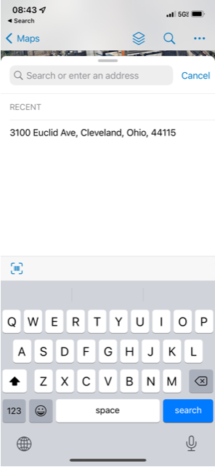

Use Search to look up and zoom to a specific address.

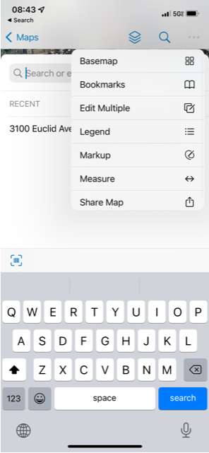

**Ellipses drop down includes more menu options:**

**Basemap** – expands menu to choose a different basemap

**Bookmarks** – allows creation of bookmarked locations

**Edit Multiple** – option to edit more than one piece of data

**Legend** – expands Legend of map

**Markup** – creates Markup layer (*is not permanent layer*)

**Measure** – opens Measurement tool

**Share Map** – allows sharing of map to email, etc.

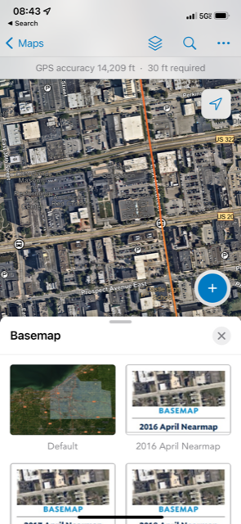

Clicking the Ellipses menu and choosing Basemap opens a menu with more options to use for your basemap.

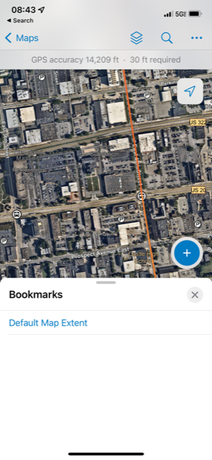

Clicking the Ellipses menu and choosing Bookmarks opens a menu with more options to create and access Bookmarks.

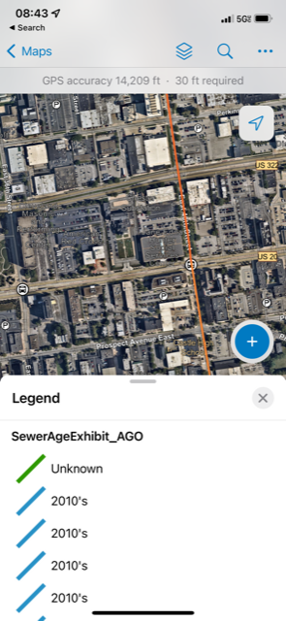

Clicking the Ellipses menu and choosing Legend displays the Legend of any layers visible/turned on in the Layer List.

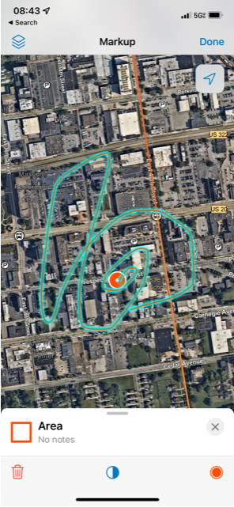

Clicking the Ellipses menu and choosing Markup allows you to create a Markup layer.

**This layer is not accessible outside of Field Maps.**

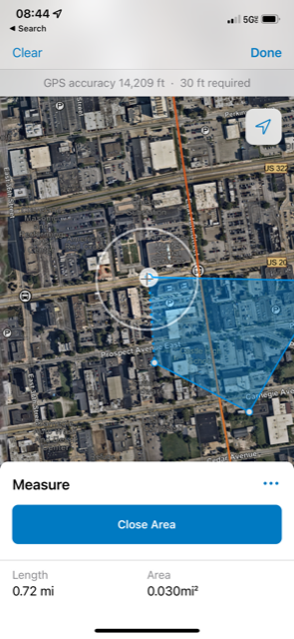

Clicking the Ellipses menu and choosing Measure opens a tool to calculate distance or area measurements.

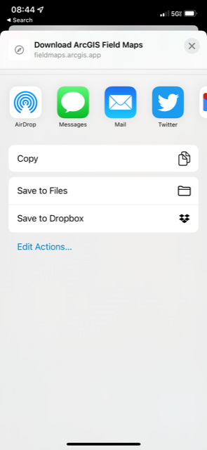

Clicking the Ellipses menu and choosing Share Map allows you to transmit the map via a variety of options.

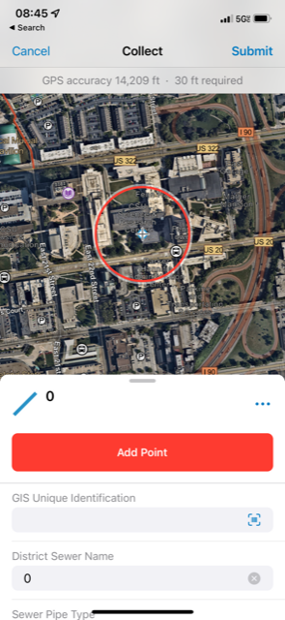 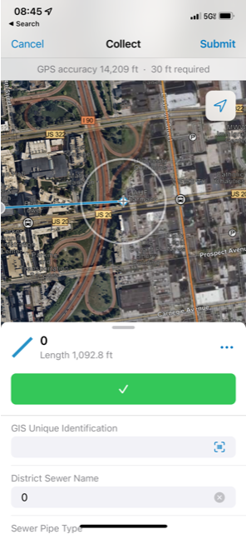 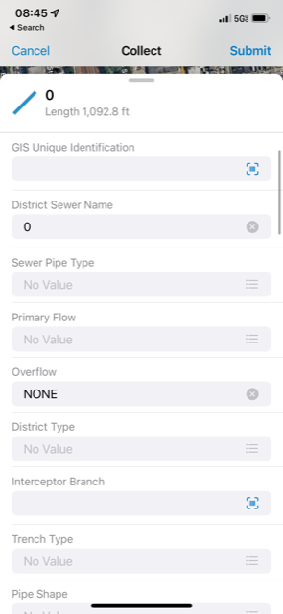

 Clicking the blue plus sign in the bottom right corner of the application will open data Collection.

Any layer turned on/visible in the map will appear as a collectable layer.

**If you do not see the layer, make sure it is turned on/visible in the Layer List.**

Use the Add Point button to create a point. If creating a line or polygon, use the Add Point button to create the first point, then move the map to the next location to then Add Point in the subsequent locations.



When a point, line or polygon has been created, fill out the appropriate data in the layer and hit Submit in the top right corner of the application.

**Your data edits will not be completed to the database unless you hit Submit.**